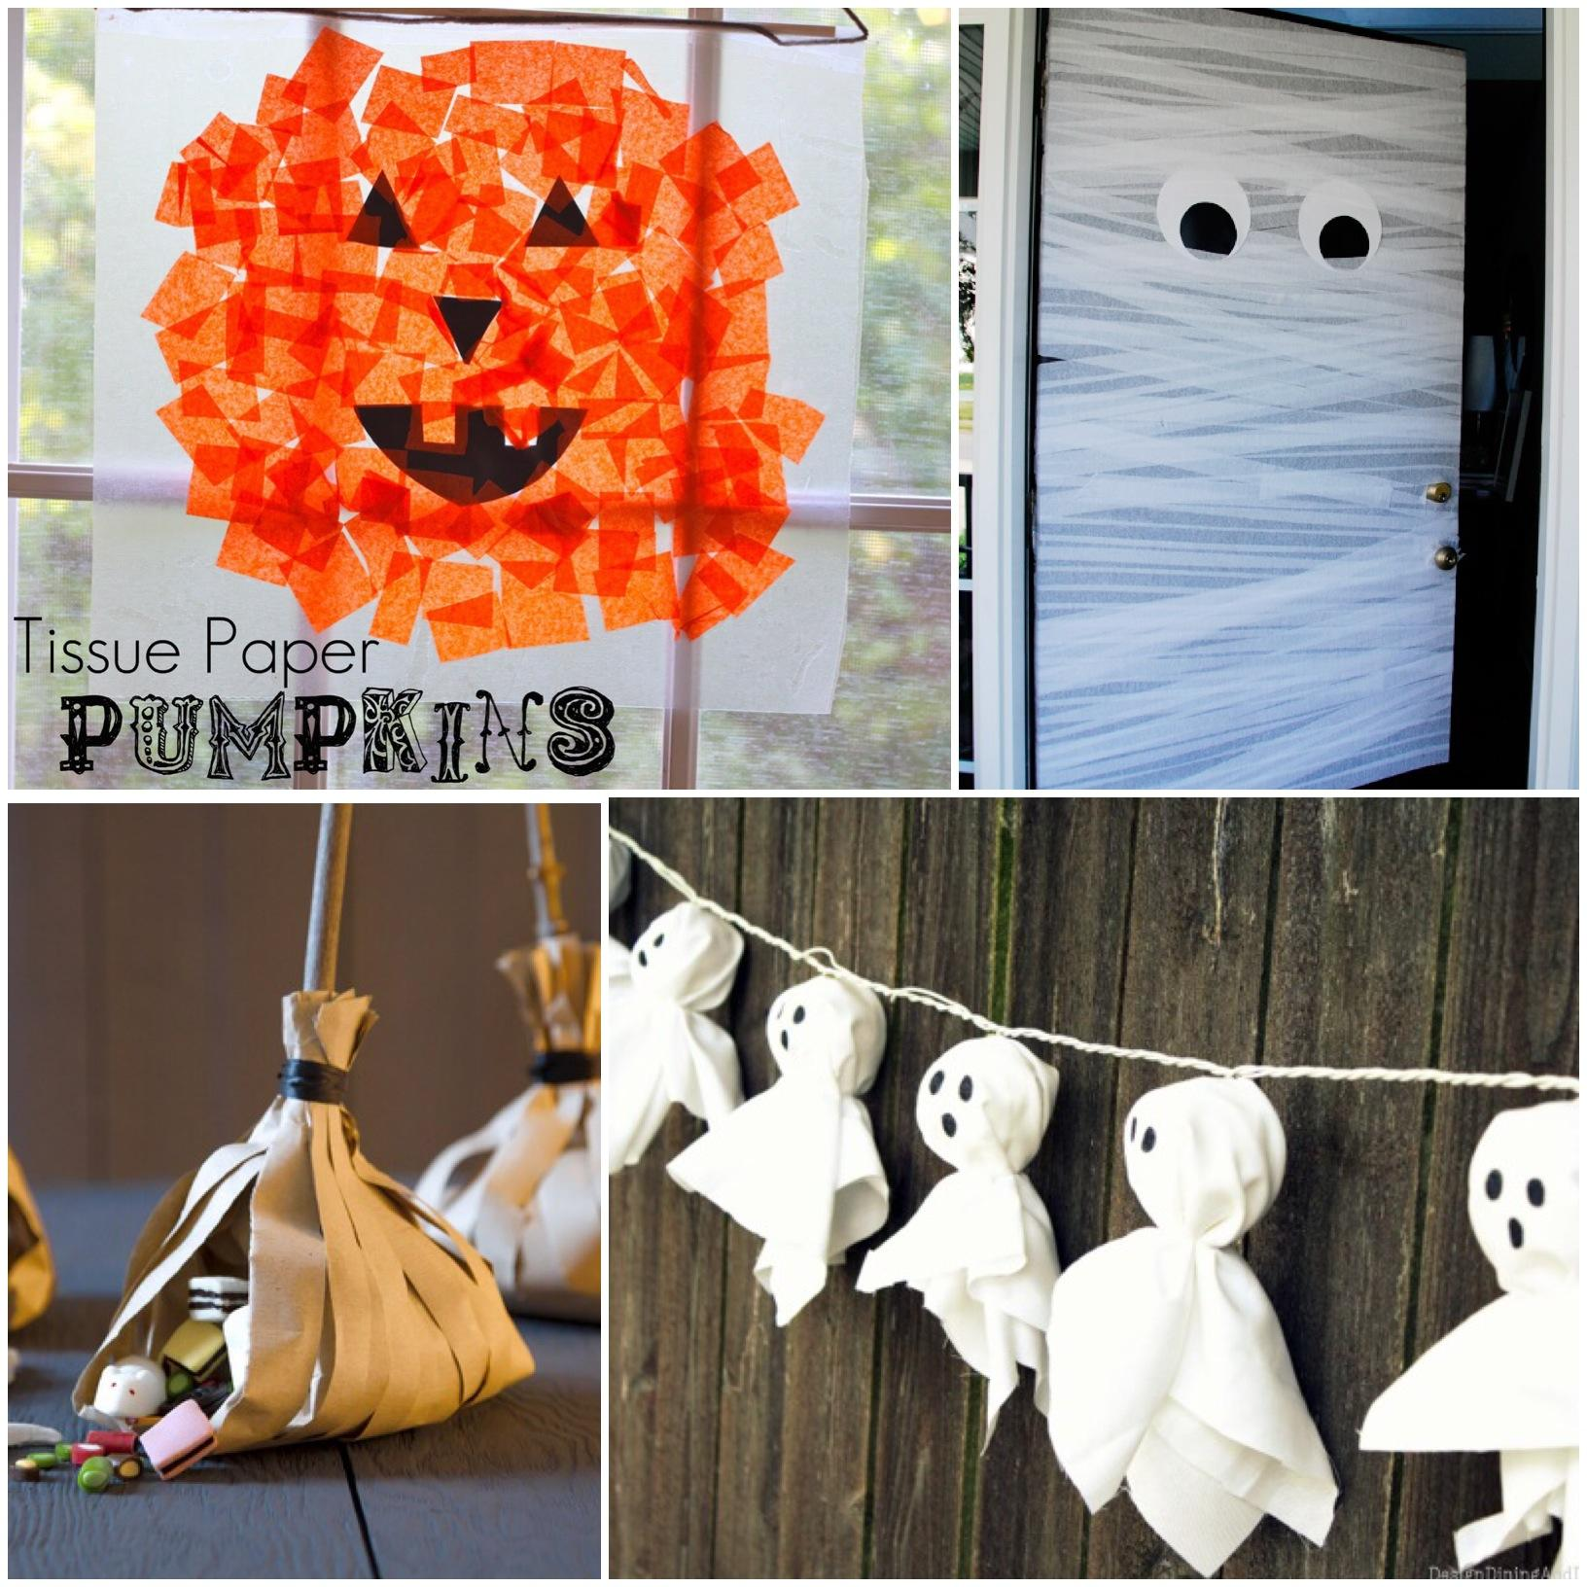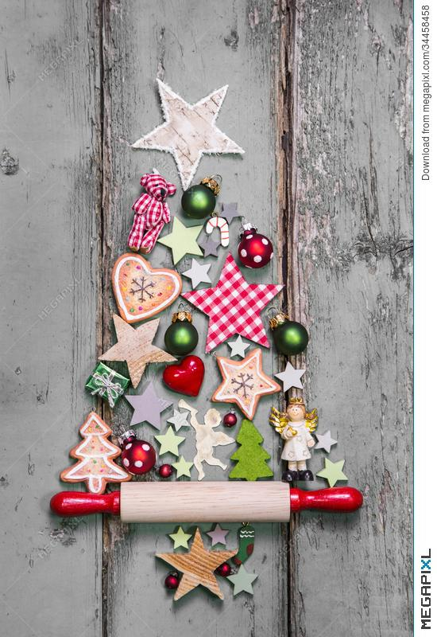
ART ON WHEELS AND SHABBY CHIC FOR KIDS..
PRESENTS:
Happy Holiday Club
An enrichment after school program
(sponsored by VVCM PTO)
* Your child will have fun creating projects that include Halloween, Thanksgiving and the enchanting month of Christmas!
We will be making projects from “Haunting” to “magical” as we travel the weeks of the seasons. We will be using materials such as:
Wood, glass, cardstock paper(design), fabrics, ribbon, buttons, gems, glitter…..and much more.

WHEN: Thursdays 2:30-3:30
10/24,10/31,11/7,11/14,11/21,12/5,12/12,12/19 (8 session)
WHERE: Valley View Charter Montessori (classroom C5)
Cost: $160.00 includes all supplies, materials and instruction

Checks payable to: Nicole Macauley (530)903-6666
Check out my FB page: Art on Wheels and Shabby Chic for kids

